**Visual Programming**

**Project Report**



A PROJECT REPORT ON

# “SCHOOL MANAGEMENT SYSTEM”

**Submitted by**

**M. Azam Kamal. Enrolment # 02-134172-189**

**M. Ahmed Siddiqui. Enrolment # 02-134172-141**

**Zohaib Sheraz Mughal. Enrolment # 02-134172-084**

**BAHRIA UNIVERSITY KARACHI CAMPUS**

*(Department of Computer Science)*

# Department of Computer Science



# CERTIFICATE

Certified that the project work entitled **“SCHOOL MANAGEMENT SYSTEM”** is a bona fide workcarried out by

**MUHAMMAD AZAM KAMAL (02-134172-189)**

**MUHAMMAD AHMED SIDDQUI (02-134172-141)**

**ZOHAIB SHERAZ MUGHAL (02-134172-084)**

………………………….|..…………………………

**Sir Bilal Vohra | Sir Malik M Ali**

**(Lab Engineer | Assistant Prof)**

1. **Introduction:**

The School Management System is designed for better administration of

Students, Employees and management. This management software very

Gracefully handles all the requirements for easy school management.

This system features makes it possible to add and edit school faculty member records, students records as well as staff records. Admin will be provided full access to all the

Records.

The main purpose of using School Management System Project is to avoid manual problems and also documentation storage problem we can’t maintain long period data that’s why we used computerized system to overcome all problem related to school’s data storing and other areas.

School Management System will replace the paper-based data collection and information exchange system among the various departments of a particular school.

1. **Tools/Software & Language Description:**

* The entire system is coded in C# language via Visual Studio 2013.
* GUI Forms
* SQL Server 2012 used as Database
* itextsharp dll for PDF Generation
* bunifu dll for additional design.

### 3. Project Modules:

* Student Information
* Employee Information
* Fees ( Generation by Class / Individual)
* Student and Employee Attendance (Attached Spreadsheets Screenshots as guided)

1. **ERD:**
2. **GUI Screenshots:**

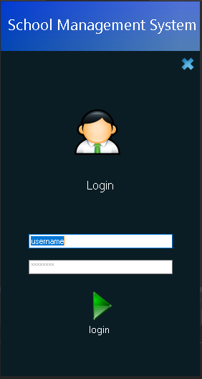



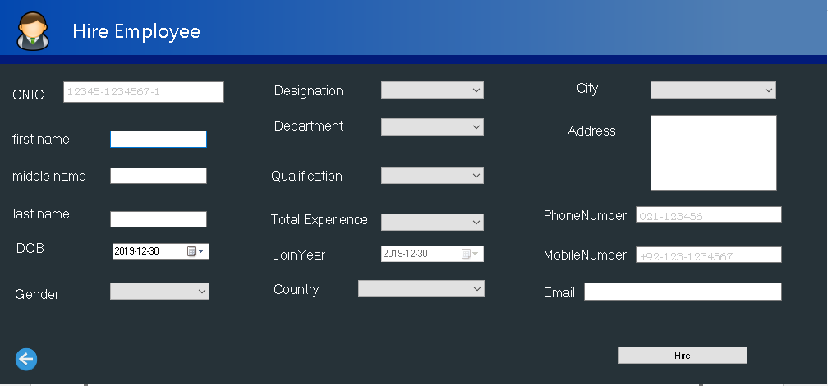

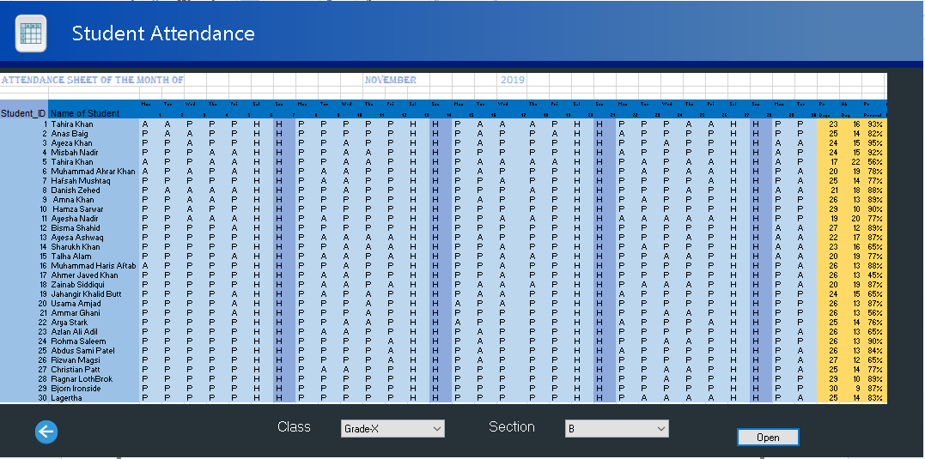

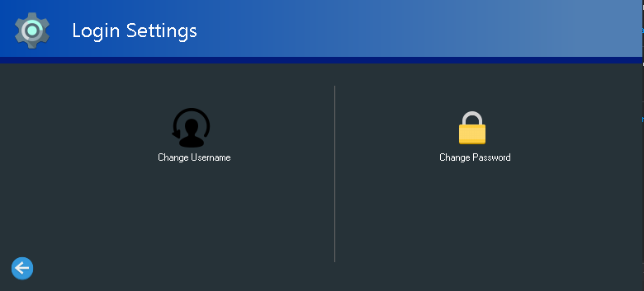

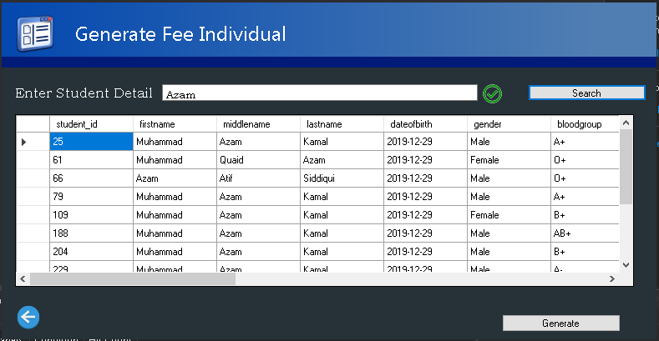

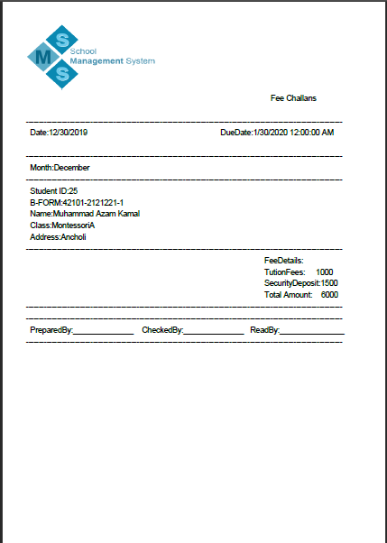

1. **Important Project Code:**

* **Searching:**

public void search()

{

//Textbox Contains Space Or Not

bool hasspace = srch_stud_TextBox.Text.Contains(" ");

if (hasspace)

{

string full = srch_stud_TextBox.Text;

int onespace = full.IndexOf(" ");

string first = full.Substring(0, onespace);

string second = full.Substring(onespace + 1);

int twospace = second.IndexOf(" ");

//One Space

if (twospace == -1)

{

command = new SqlCommand("[searchstudent2name]", MyConnection);

command.CommandType = CommandType.StoredProcedure;

command.Parameters.AddWithValue("@name", first);

command.Parameters.AddWithValue("@last", second);

try

{

MyConnection.Open();

SqlDataReader rdr = command.ExecuteReader();

DataTable dt = new DataTable();

dt.Load(rdr);

dataGridView1.AutoGenerateColumns = true;

dataGridView1.DataSource = dt;

}

catch (Exception Ex)

{

MessageBox.Show(Ex.Message.ToString());

}

finally

{

MyConnection.Close();

}

}

//TWO Space

else if (twospace > -1)

{

string secondf = second.Substring(0, twospace);

string third = second.Substring(twospace + 1);

command = new SqlCommand("[searchstudent3name]", MyConnection);

command.CommandType = CommandType.StoredProcedure;

command.Parameters.AddWithValue("@name", first);

command.Parameters.AddWithValue("@middle", secondf);

command.Parameters.AddWithValue("@last", third);

try

{

MyConnection.Open();

SqlDataReader rdr = command.ExecuteReader();

DataTable dt = new DataTable();

dt.Load(rdr);

dataGridView1.AutoGenerateColumns = true;

dataGridView1.DataSource = dt;

}

catch (Exception Ex)

{

MessageBox.Show(Ex.Message.ToString());

}

finally

{

MyConnection.Close();

}

}

}

//Without Space Search

else if (!hasspace)

{

//ID Search

int number;

bool result = Int32.TryParse(srch_stud_TextBox.Text, out number);

if (result)

{

command = new SqlCommand("[searchstudentid]", MyConnection);

command.CommandType = CommandType.StoredProcedure;

command.Parameters.AddWithValue("@id", srch_stud_TextBox.Text);

try

{

MyConnection.Open();

SqlDataReader rdr = command.ExecuteReader();

DataTable dt = new DataTable();

dt.Load(rdr);

dataGridView1.AutoGenerateColumns = true;

dataGridView1.DataSource = dt;

}

catch (Exception Ex)

{

MessageBox.Show(Ex.Message.ToString());

}

finally

{

MyConnection.Close();

}

}

//Name&NIC search

else

{

command = new SqlCommand("[searchstudent1name]", MyConnection);

command.CommandType = CommandType.StoredProcedure;

command.Parameters.AddWithValue("@name", srch_stud_TextBox.Text);

command.Parameters.AddWithValue("@last", srch_stud_TextBox.Text);

command.Parameters.AddWithValue("@middle", srch_stud_TextBox.Text);

command.Parameters.AddWithValue("@cnic", srch_stud_TextBox.Text);

try

{

MyConnection.Open();

SqlDataReader rdr = command.ExecuteReader();

DataTable dt = new DataTable();

dt.Load(rdr);

dataGridView1.AutoGenerateColumns = true;

dataGridView1.DataSource = dt;

}

catch (Exception Ex)

{

MessageBox.Show(Ex.Message.ToString());

}

finally

{

MyConnection.Close();

}

}

}

}

* 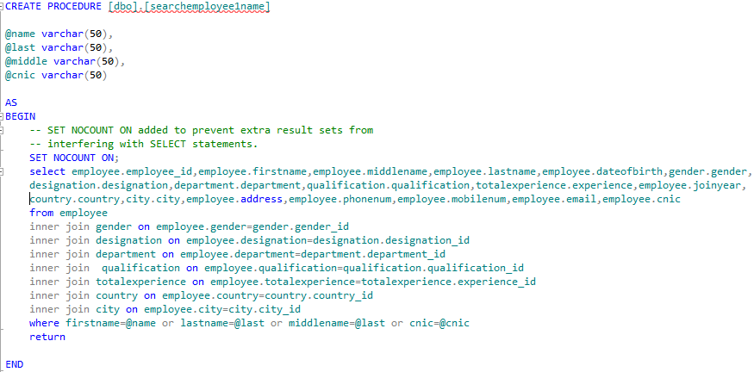**SQL Query (Joins):**
* **Folder Dialog and PDF for Fee:**

FolderBrowserDialog folderDlg = new FolderBrowserDialog();

folderDlg.ShowNewFolderButton = true;

DialogResult result = folderDlg.ShowDialog();

if (result == DialogResult.OK)

{

Environment.SpecialFolder root = folderDlg.RootFolder;

}

if (folderDlg.SelectedPath == "")

{

MessageBox.Show("Please choose a valid location");

}

else

{

// Generating Fee for All Students in Section

for (int i = 0; i < totalstudents - 1; i++)

{

//Getting values from DGV

value1 = Convert.ToInt32(dataGridView1.Rows[i].Cells[0].Value);

ID = value1;

value2 = Convert.ToString(dataGridView1.Rows[i].Cells[1].Value);

fn = value2;

value3 = Convert.ToString(dataGridView1.Rows[i].Cells[2].Value);

mn = value3;

value4 = Convert.ToString(dataGridView1.Rows[i].Cells[3].Value);

ln = value4;

value9 = Convert.ToString(dataGridView1.Rows[i].Cells[8].Value);

cl = value9;

value10 = Convert.ToString(dataGridView1.Rows[i].Cells[9].Value);

sc = value10;

value13 = Convert.ToString(dataGridView1.Rows[i].Cells[12].Value);

an = value13;

value17 = Convert.ToString(dataGridView1.Rows[i].Cells[16].Value);

ad = value17;

//Generating PDF File

Connecting c = new Connecting();

date = DateTime.Now.ToShortDateString();

mon = DateTime.Today.ToString("MMMMMMMMMM");

month = mon.ToString();

var dtt = new DateTime(DateTime.Today.Year, DateTime.Today.Month, DateTime.Today.Day);

Due = dtt.AddMonths(1).ToString();

string filename = fn + " " + mn + " " + ln + " Fee Challan.pdf";

path = System.IO.Path.Combine(folderDlg.SelectedPath, filename);

Document d = new Document();

FileStream file = File.Create(path);

PdfWriter.GetInstance(d, file);

c.fee(ID, fn, mn, ln, CL, SC, ad, an, date, Due, month, amt);

Image logo = Image.GetInstance(@"C:\Users\Azam\Desktop\Semester 5\Vp lab\VP Project\SMS 9.11\School Managment System\School Managment System\images\final_logo.png");

logo.ScaleAbsolute(200, 100);

d.Open();

d.Add(logo);

d.Add(new Paragraph(" Fee Challans"));

d.Add(new Paragraph(" "));

d.Add(new Paragraph("---------------------------------------------------------------------------------------------------------------------------"));

d.Add(new Paragraph(" Date:" + date + " DueDate:" + Due + "

}

}